# CS 340 README

## About the Project/Project Title

This project is a database maintenance code using python to interface with MongoDB to search for and find suitable candidates for rescue dogs using the Austin Animal Center

## Motivation

The Austin Animal Center has a large collection of data pertaining to the various animals, breeds, etc in it’s facility. This project will help keep track of, organize, and easily find candidates for various service animals

## Getting Started

For your local copy to function make sure your main.py is in the same directory as your main.py. Each module should work properly given you have entered the right username and password into the correct field for the AnimalShelter class.

## Installation

Recommended tools:

MongoDB

Python 3.6 with PyMongo

Jupyter Notebook

## Usage

The dashboard limits searches to 10 results per page with the ability to manually filter search results 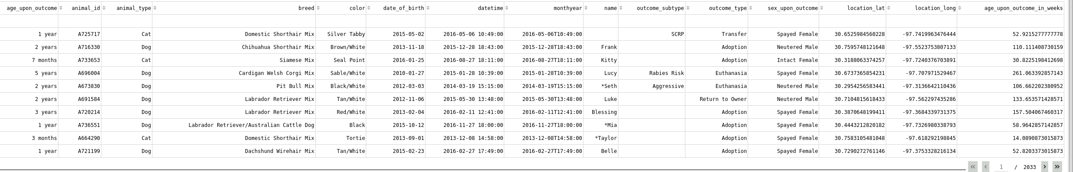

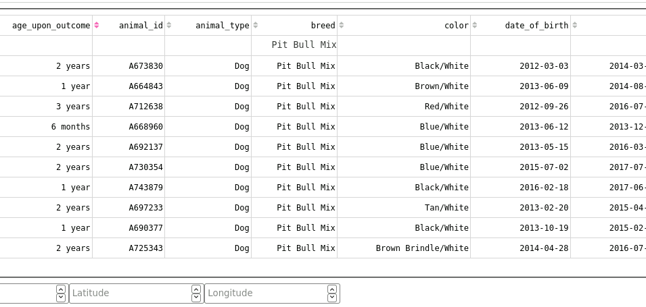

The program also has a drop down menu to filter for dogs that are suitable for water rescue, mountain or wilderness rescue, and disaster or individual tracking. As well as an option to reset

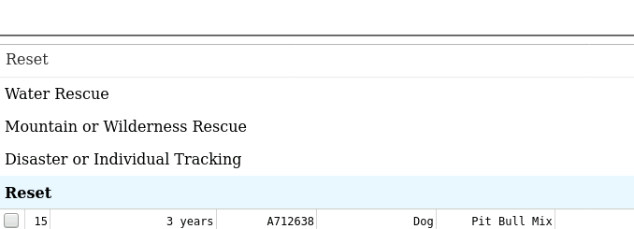

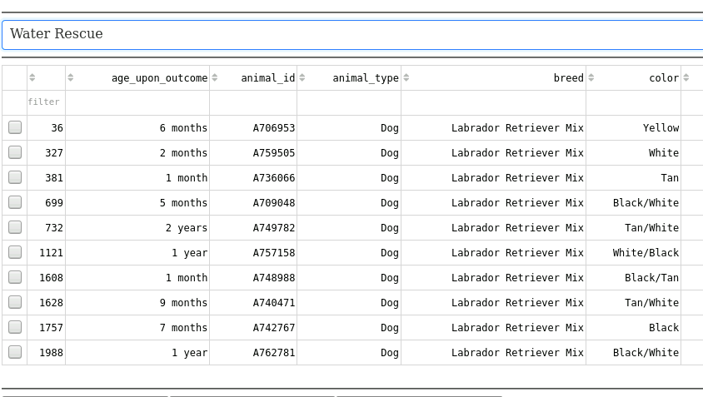

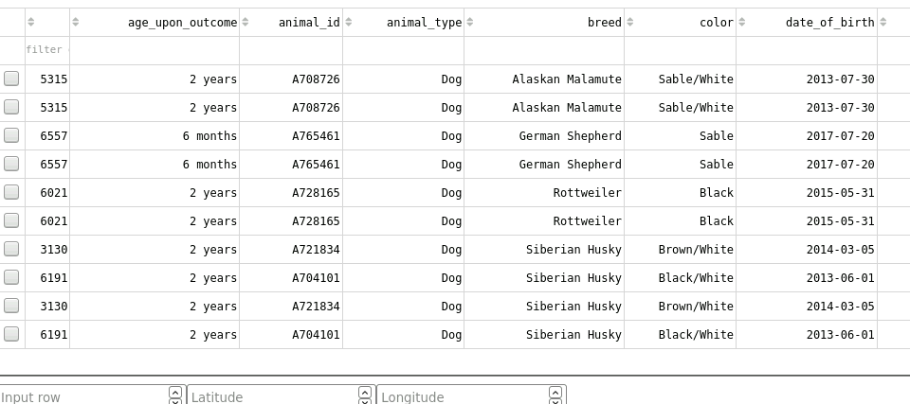

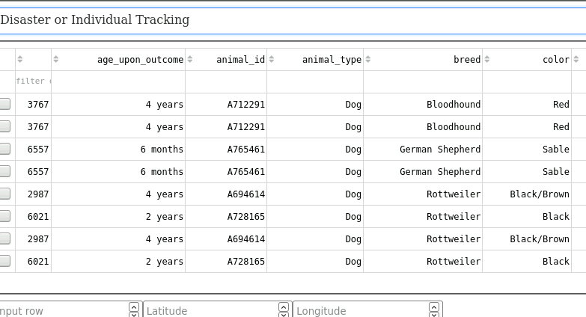

A graph exists that shows the amount of current animals suitable for each rescue

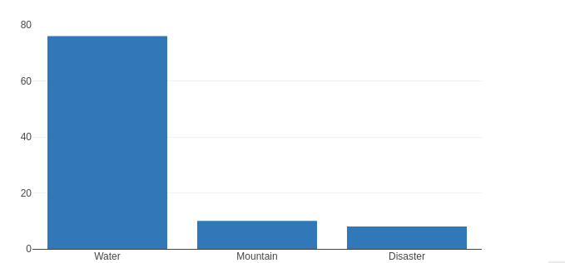

As well as a map that can be used to look up the specific location of an animal

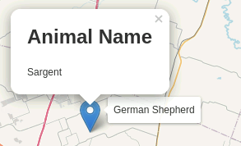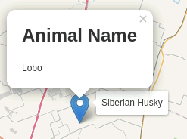

### Tests

An easy way to test your program is to load in the data and search for yourself. If done correctly, a specific search query should load what you are looking for. On the map just choose the row for the animal you are looking for.

## Contact

Corey Wright